ECR:

Codebuild auto trigger:

Kubernetes deployed services: **(updated)**

Kubernetes running pods: **(updated)**

K8 deployment describes: **(updated)**  
  
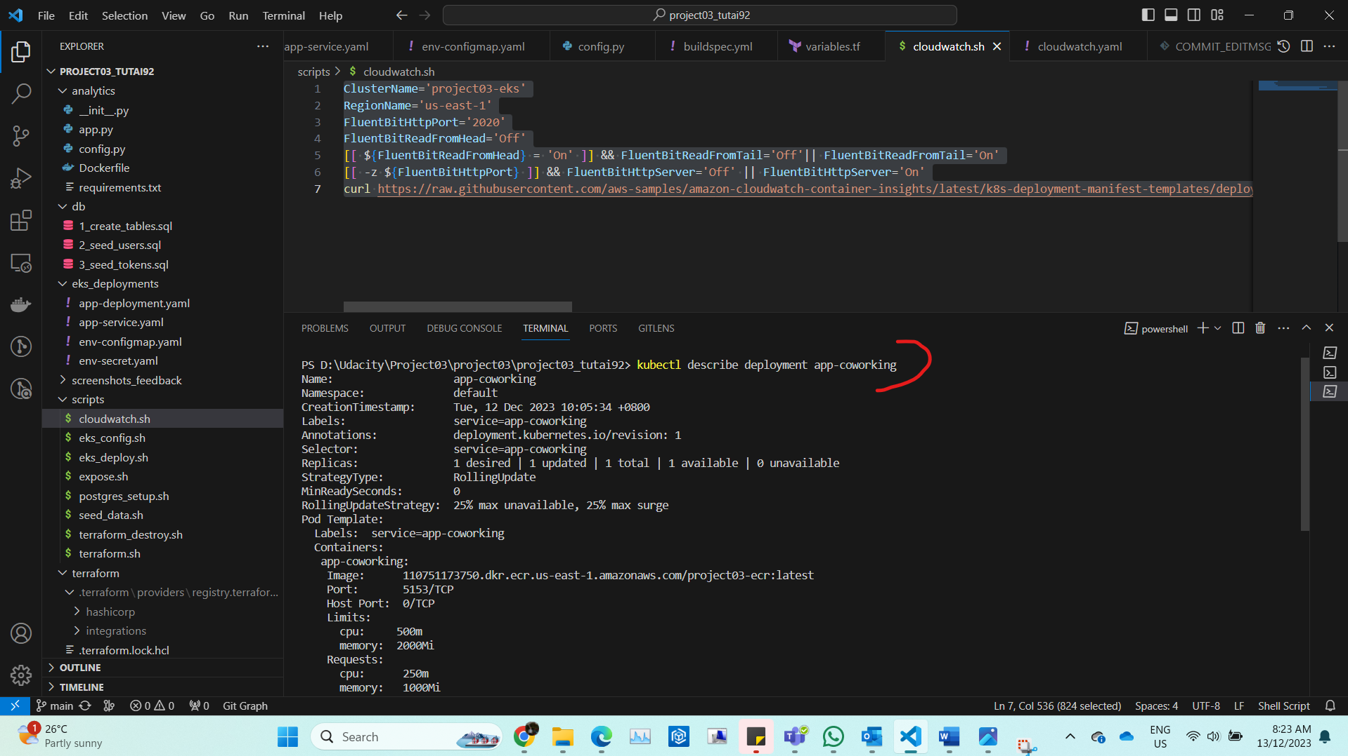

K8 db setup with Helm:

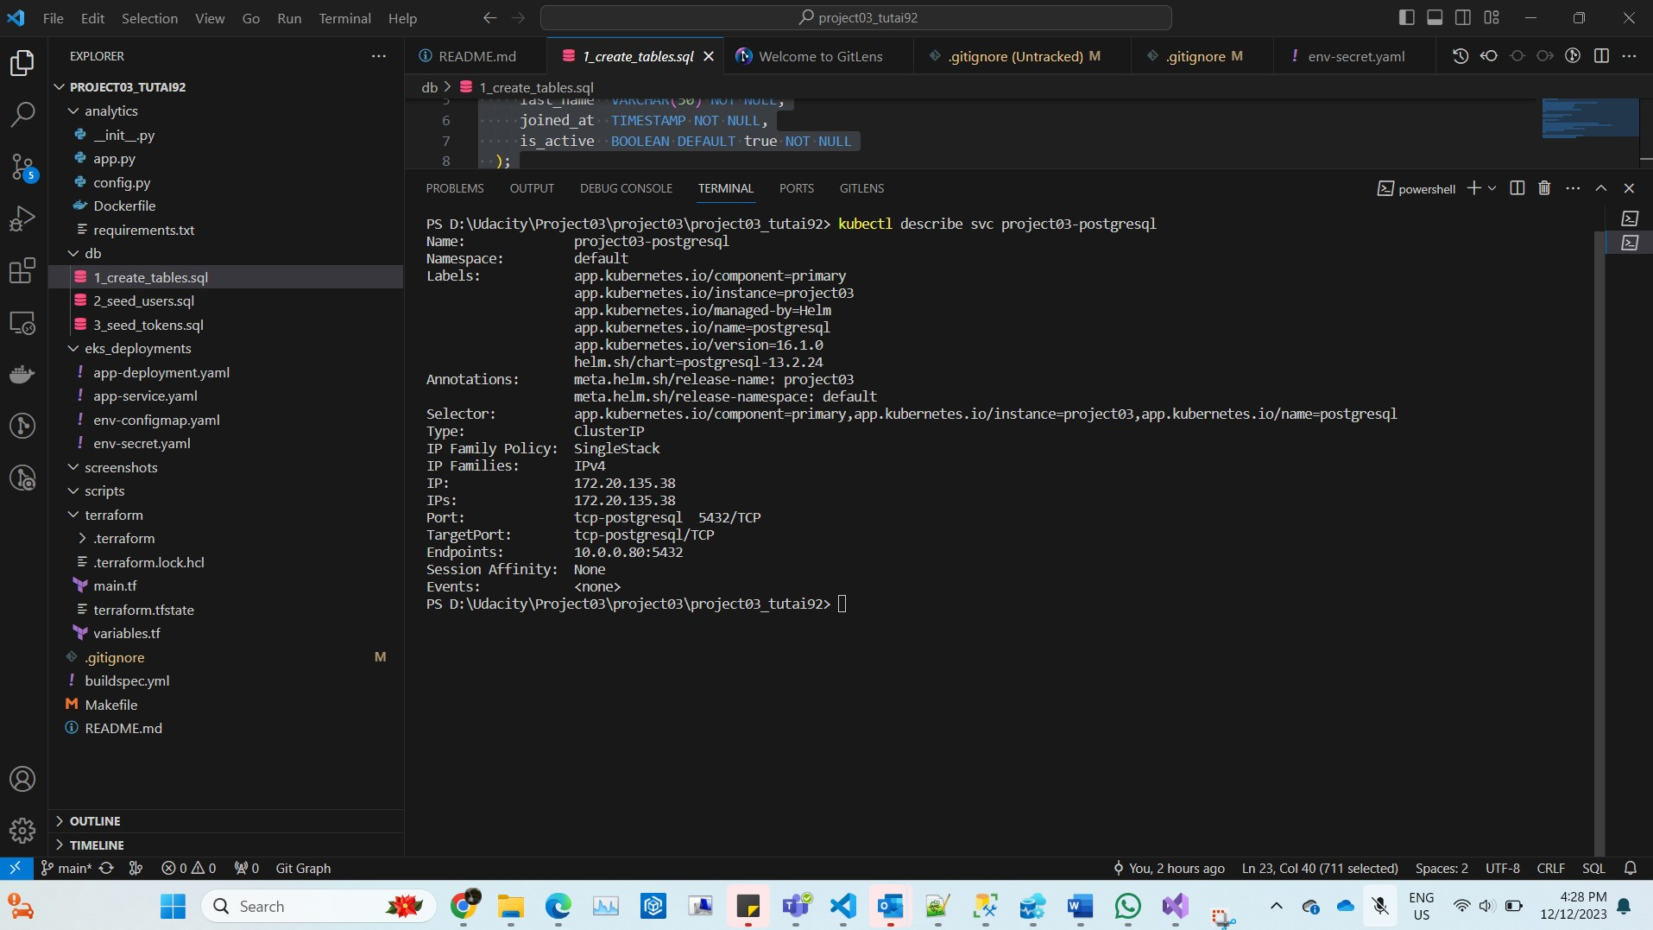

Loggin in CloudWatch: (**(updated)**

API results:   
  
